Tian Qiu

MA 366 Lab 11 Linear Systems

1.

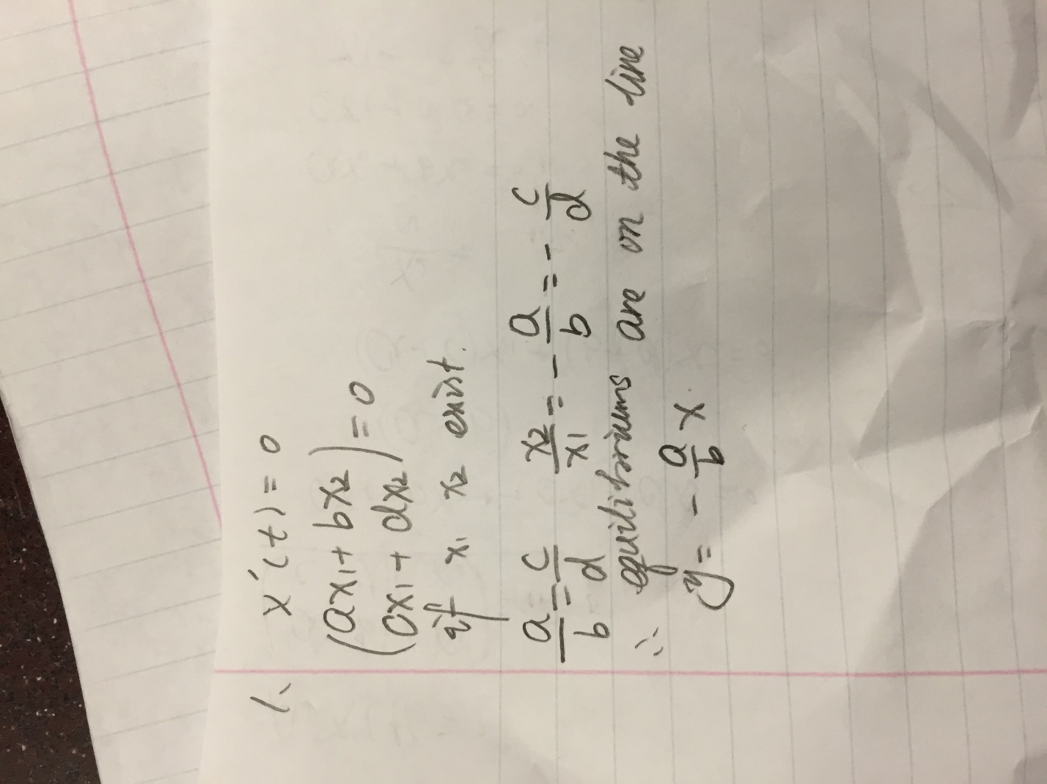

2. 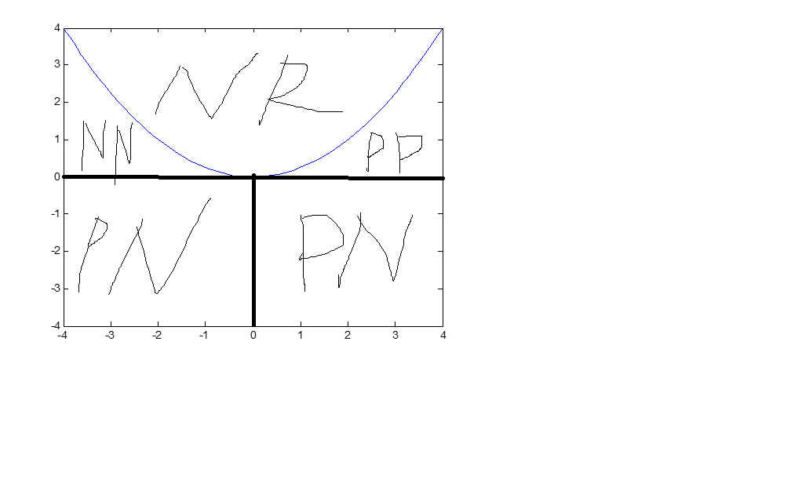

3. 

(a) Origin is a source

(b) Yes. I used initial value (0, 1). And the plot is not spiral out from origin.

4.

>> A = [0 -1; 1 3]

A =

0 -1

1 3

>> [B, D] = eig(A)

B =

-0.9342 0.3568

0.3568 -0.9342

D =

0.3820 0

0 2.6180

So, the eigenvalues are 0.3820 and 2.6180

The eigenvectors are ( -0.9342 ; 0.3568 ) and (0.3568; -0.9342).

5.

Because in the PP region, all the real part of eigenvalues is positive, which means the portrait is moving away from the origin.

6

(a) Origin is a sink

(b) Yes. I used initial value (0, 1). And the plot is not spiral in.

>> A = [0 -1; 1 -3]

A =

0 -1

1 -3

>> [B, D] = eig(A)

B =

0.9342 0.3568

0.3568 0.9342

D =

-0.3820 0

0 -2.6180

So, the eigenvalues are -0.3820 and -2.6180

The eigenvectors are ( 0.9342 ; 0.3568 ) and (0.3568; 0.9342).

7.



(a) Origin is a saddle

(b) Yes. I used initial value (1, 1), which is straight line solution to prove origin is a saddle point.

>> A = [0 -1; -1 0]

A =

0 -1

-1 0

>> [B, D] = eig(A)

B =

-0.7071 -0.7071

-0.7071 0.7071

D =

-1 0

0 1

So, the eigenvalues are -1 and 1

The eigenvectors are ( -0.7071 ; -0.7071 ) and (-0.7071 ; 0.7071 ).

8. 





When eigenvalues are complex number with negative real part, the origin is spiral sink.

When eigenvalues are complex number with positive real part, the origin is spiral source.

When eigenvalue are complex numbers without real part, the origin is center.

If both eigenvalues are negative, the origin is a sink.

If both eigenvalues are positive, the origin is a source

If one eigenvalue is positive and the other one is negative, the origin is a saddle point.